YEAR 8 | Music Taught Content | Assessment
HT 1 | The Blues (NCP, NCC, NCL, NCU, NCS). This unit gives students the opportunity to both perform and compose within the genre of the Blues using the 12 bar blues chord structure, walking or boogie bass line, Jackass Blues melody and then adding their own improvisation. Students will learn the history and musical features behind the Blues through listening exercises and class discussions. (7-2, 7-4) | Summative assessments on the performance of the blues piece.  Low stakes quizzes  Formative assessment and feedback within lessons
HT 2 | Ukulele 1 (NCP, NCS) This unit introduces students to performing on the ukulele. The focus is on playing the chords of C, F, Am and G through a variety of different songs where students will read from scores using standard chord diagrams and work on performing in an ensemble. (7-1, 7-2, 7-4) | Assessments will happen throughout the unit as each skill is mastered. Verbal feedback will be given lesson by lesson for students to make maximum progress.
HT 3 | Theme and variation (NCP, NCC, NCL, NCU, NCS). Within this unit, students will learn the structure of Theme and Variation and a variety of ways to develop melodies. They will learn a basic theme (Freres Jaques) on the keyboard and through the series of lessons develop their composition using simple techniques such as dynamics, tempo and instrumentation moving onto more complex concepts such as canon, retrograde, major and minor tonalities. (7-3) | Summative assessment will take place at the end of the unit based on students’ final compositions  Low stakes quizzes
JHT 4 | Musescore II (NCC, NCU, NCS) Following on from the Musescore I project, this unit give students opportunities to recap and build on the skills they already have used. Compositions using the software will use Triadic chords in root and inverted forms, broken chords (different to unit 1), learning how to write for bass clef and understanding the relationship between treble and class clef. Students will also review composing in structures and manipulate the concepts to compose a backing track for a song. (7-4) | Summative assessment at the end of the project  Formative assessment though each lesson with feedback and support for improvement.  Low stakes quizzes
HT 5 | Two’s a Crowd (NCP, NCC). This unit expands on the keyboard skills built from year 7. The focus for this performance is working in an ensemble as the piece is written for 4 independent hands and taking independent parts and timing. The opportunity for improvisation increases the challenge for students with the scope for ideas to be simplistic though to complex (7-1, 7-4) | Summarise assessment on final performance  Formative assessment with feedback for improvement throughout the unit.
HT 6 | Songwriting (NCC, NCP, NCS, NCU). This unit uses the work completed in HT4 and creates a song using their musescore backing as a track. Working on fitting a melody to an accompaniment as well as working within a verse -chorus structure students work in groups to write lyrics and complete a finished product. (7-1, 7-4, 8-4) | Formative assessment throughout the unit  Low stakes quizzes  Summative assessment of final composition

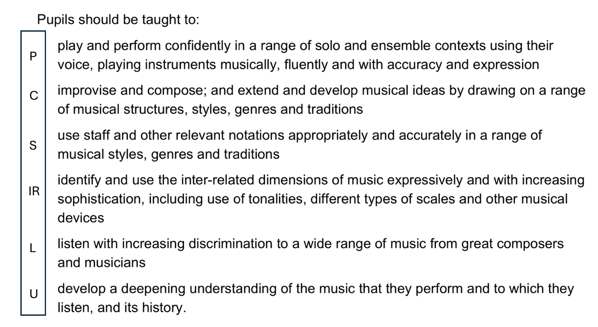
National Curriculum for Music

